بسم الله الرحمن الرحيم

قال الله العليم :
}إِنَّمَا يَخْشَى اللَّهَ مِنْ عِبَادِهِ الْعُلَمَاءُ { فاطر:28

وقال الرسول عليه الصلاة والسلام :
" من سلك طريقًا يطلبُ فيه علمًا ، سلك اللهُ به طريقًا من طرقِ الجنةِ ... "
المحدث : الألباني
خلاصة حكم المحدث : صحيح

Certification of Research

I certify that I have reviewed this project done by: Ahmad jamal Hariri 1008381 – Abdullah salem khered 1008623 during the 1st or 2nd semester of the academic year 2014. And I approve the project submission for discussion by the project responsible committee to grade it as the graduation project degree in computer science.

Supervisor: Dr.Jonathan (Yahya) Cazalas
Signature: …………………

Declaration

We certify that the implementation of this graduation project has been done by our own efforts. This includes the preparation and writing of the analysis, design, programming and documentation. We have got assistance during the implementation period of this project, after Allah, from the references mentioned in this thesis, and Allah is the witnesses of what we say.

Student Name: Ahmad jamal hariri Student Name: Abdullah salem khered
Student ID: 1008381 Student ID: 1008623
E-mail: Ahmadgjh@gmail.com E-mail: akhered20@gmail.com
Mobile: 0505500259 Mobile: 0509230468
Signature: ............................. Signature: .............................

Approximate Query Location In mobile Computing ( using GPU )

Abstract
In this project we will deal with a famous problem in the domain of finding the approximate query location in mobile computing by using General-purpose computing on GPU.

Aim of the project
The aim is to learn parallel programming on GPUs using NVidia’s CUDA and use this knowledge to solve problems & improve the evaluations in the domain of real-time approximate query location in mobile computing.

Dedicated to

To our great families who provided a generous assistant as always during this in order to complete this project.

Acknowledgments

Special thanks to Dr. Jonathan ( Yahya ) Cazalas for his and help in achieving the project goals. Thanks to Dr. Aiiad Albeshri for his coordination and management for the senior project.
Wish you all the best ,

Table of Content

Certification of Research iii
Declaration iv
Abstract v
Aim of the project v
Dedicated to vi
Acknowledgments vii
Table of Content viii
List of Figures xi
List of Tables xiv
Chapter 1 : Introduction 2
1.1 Motivation 4
1.2 Consideration 4
1.3 Project Proposal 5
1.3.1 Problem definition 5
1.4 Project scope 5
1.5 Project type 6
1.6 The outcome 6
1.7 Target Users 6
1.8 Suggested solution 7
1.9 Project Management 8
1.9.1 Work Breakdown Structure (WBC) 8
1.9.2 Time Estimates 10
1.9.3 Gannt chart 11
Chapter 2 : Literature Search and Evaluation 13
2.1 Planning the literature search 13
2.2 Summary for the first reference 14
2.2.1 Problem definition 15
2.2.2 Solution 15
2.2.3 Evaluation 16
2.3 References :- 17
2.4 Skills 21
Chapter 3 : Analysis & design 24
3.1 Requirements Specification 24
3.1.1 Functional Requirements :- 24
3.1.2 Nonfunctional Requirements :- 24
3.2 Data Requirements :- 24
3.3 Hardware :- 25
3.4 Software :- 25
3.5 Activities and Actions 26
3.5.1 Use case diagram :- 26
3.5.2 Flow chart :- 27
3.5.3 Class diagram :- 28
Chapter 4 : Implementation 31
4.1 The coding is divided into 10 parts 31
4.2 Maintenance 31
4.3 Interface 32
Chapter 5 : Testing 36
5.1 Some of the test cases : 36
5.2 Compare , Assess The Results 40
5.3 Conclusion for testing phase 48
Chapter 6 : Conclusion 50
6.1 List of references :- 52
6.1.1 Research papers : 52
6.1.2 Book : 52
6.1.3 Definitions : 52
Appendix A : Code 54
A.1 Important functions :- 54

List of Figures
Chapter 1
1.1 Figure WBS…………………………………………………………………………………… | 9
1.2 Figure TimeEstimates………………………………………………………………………… | 10
1.3 Figure GanntChart…………………………………………………………………………… | 11
Chapter 3
3.1 Figure  Use case diagram…………………………………………………………………… | 26
3.2 Figure  Flow chart…………………………………………………………………………… | 27
3.3 Figure  Class diagram…………………………………………………………………………… | 28
Chapter 4  4.1 Figure  choice entering …………………………………………………………………… | 32
4.2 Figure  Object ID entering ………………………………………………………………… | 33

4.2 Figure  Blue circle around the object ……………………………………………………… | 34

Chapter 5
5.1 Figure  Compare CPU exact & approximate …………………………………………………… | 36
5.2 Figure  Compare GPU exact & approximate (Guaranteed neighbors)……………………… | 37
5.3 Figure  Compare GPU exact & approximate (All possible neighbors)…………………… | 38
5.4 Figure  Compare GPU exact & approximate (Best approximation)……………………… | 39
5.5 Figure  Test compare CPU & GPU exact (Num. of objects)………………………………… | 40
5.6 Figure  Test GPU exact (Num. of threads)……………………………………………………. | 41
5.7 Figure  Test GPU exact (Query range)…….…………………………………………………… | 42
5.8 Figure  Test Approx. vs. exact CPU……………….…………………………………………. | 43
5.9 Figure  Test Approx. vs. exact GPU………………………………………………………………………… | 44
5.10 Figure  Test Approx. vs. exact GPU (Guaranteed neighbors)…………………………… | 45
5.11 Figure  Test Approx. vs. exact GPU (All possible neighbors)……………………………… | 46
5.12 Figure  Test Approx. vs. exact GPU (Best approximation)……………………………… | 47
List of Tables
Chapter 2
2.1 Table  The CUDA by example book evaluation …………………………… |  | 17
2.2 Table  Processing Approximate Moving Range Queries in Mobile Sensor Environments evaluation……………………………………………………………… |  | 18
2.3 Table  CAWA: Continuous Approximate Where-About Queries research paper evaluation……………………………………………………………… |  | 19
Chapter 5
5.1 Table  Test compare CPU & GPU exact (Num. of objects)……………………… |  | 40
5.2 Table  Test GPU exact (Num. of threads)…………………………………… |  | 41
5.3 Table  Test GPU exact (Query range)…………………………………………………….. |  | 42
5.4 Table  Test Approx. vs. exact CPU …………………………………………… |  | 43
5.5 Table  Test Approx. vs. exact GPU …………………………………………… | 44
5.6 Table  Test Approx. vs. exact GPU (Guaranteed neighbors)………………… | 45
5.7 Table  Test Approx. vs. exact GPU (All possible neighbors)………………… |  | 46
5.8 Table  Test Approx. vs. exact GPU (Best approximation)……………… |  | 47

Chapter 1
Introduction

Chapter 1 : Introduction

The title of the project is solving approximate query locations in mobile computing. It means that if we have an environment where tens of thousands (even hundreds of thousands) of mobile objects moving around and performing queries to know where are their neighbors. For example: GPS-enabled vehicles traveling around a city, Pilgrims who are all wearing RFID tags, gamers playing massively multiplayer online role playing games (MMORPG). Such queries are called a range query or a kNN query.
The moving objects needs to know all the neighbors that are close to them in proximity, so as to not hit each other and cause an accidents.

Additionally, the locations of the objects are approximated because the update of the objects’ locations at the server are uncertain due to the continuous motion of the objects, that mean there were a long stale time in sending the queries to the server, or the object may doesn't want the other objects to know its accurate location by sending blurred coordinates , or because of bandwidth problems or …. .
During the wasted time, the neighbors may have been moved out from the objects range or at the worst case the objects may have got an accidents with the other objects.

In short, all the objects needs to get the locations of their neighbors to know where they are and to avoid them.
These scenarios are too difficult for the CPU to solve. by using the GPU to solve these queries in real-time the problem will be very easy to handle.

At present, the computers are in everywhere and the programmers goal is to increase the speed of programs and this speed depend on a piece inside the computer called CPU ( Central Processing Unit ) , but this CPU have a limited capacity . Also, There is another piece called GPU ( Graphical Processing Unit ) is dedicated for displaying graphical interfaces , but recently discovered that it could be used to increase the speed of programs by parallelizing the execution by hundreds of cores built inside the GPU while the CPU have a very few cores inside.

So, we need to apply GPU computing in the project.

GPU computing is the use of a GPU (graphics processing unit) together with a CPU to accelerate general-purpose scientific and engineering applications. It has quickly become an industry standard, enjoyed by millions of users worldwide and adopted by virtually all computing vendors.

CPU + GPU is a powerful combination because the CPUs consists of a few cores optimized for serial processing, while GPUs consists of thousands of smaller, more efficient cores designed for parallel performance. Serial portions of the code run on the CPU while parallel portions run on the GPU.

The term Parallel computing is a form of computation in which many calculations are carried out simultaneously, operating on the principle that large problems can often be divided into smaller ones, which are then solved concurrently ("in parallel").

From past until now we are facing problems in monitoring a lot of mobile objects in a huge environments. And these objects are moving randomly in real time, such as video games, traffic, pilgrims ... etc.

Mobile (objects) computing is a technology that allows transmission of data, via a computer without having to be connected to a fixed physical link. And being able to use a computing device even when being mobile and therefore changing location. Portability is one of the aspect of mobile computing.

The main goal is to do GPU computations to find the approximate locations for the objects neighbors.

1.1 Motivation

The motivation for the project is learning new things , and since there are so many huge environments ,by the GPU we can provide solution to a lot of problems people are facing these days, unlike the early days relying on just the CPU , we were have a lack of querying , controlling or monitoring objects in a big environment .

1.2 Consideration

In this project we will consider the objects will be able to send their locations by technologies such as ( RFID tags, Sensors … etc. ) to the server .

1.3 Project Proposal

1.3.1 Problem definition
The problem is about a big number of objects and those objects are moving randomly. All those objects send their locations in real-time to the server. Also, those objects want to know where their neighbors .

We tackle a challenge in processing continuous range queries: coping with data uncertainty inherently associated with location data (stale, inaccurate position).

These queries must be evaluated in REAL-TIME. Parallel programming on the GPU provide a great solution to evaluate these queries.

1.4 Project scope

The scope of this project is:

- Learn CUDA C.
- Make simulations in the GPU & CPU to solve approximate queries.
- Improve the evaluation for the approximate query locations.
- Compare the time results between the CPU & the GPU.

1.5 Project type

The type of the project is simulation-based project.

1.6 The outcome
CUDA program that parallelize the execution of large number of queries for finding ( the neighbors ) with approximate locations.

1.7 Target Users

The target users are large environments in which needs to be improved by querying to find approximate location to theirs neighbors in order to achieve their goals (avoid causing accidents, find, manage, manipulate,... etc.).

1.8 Suggested solution

First, we will create four simulations in CPU & GPU to model the environment – movement- by giving a coordinate to every object and letting it move randomly.

In the CPU we will make two simulations:

- Simulation to solve range queries using exact locations.

- Simulation to solve range queries using approximate locations.

Also, In the GPU we will make the same simulations to improve the evaluation.

The project is divided into three ideas :-

First, mobile computing.

Nowadays, the number of portable computers is increasing day after day , and the desire is to have a continuous network connectivity to the Internet .Mobile computing is an important field in today's world of networked systems.

Second, parallel computing.

Large problems can often be divided into smaller ones, which are then solved concurrently ("in parallel").

Third, the GPU

CPU only cannot deal with a big numbers of objects moving and wants know where the other objects location at real time. But parallel programming on GPU can deal with the problem.

1.9 Project Management

1.9.1 Work Breakdown Structure (WBC)

Work Breakdown Structure is one of the best ways to break a large or difficult task into more smaller, more manageable subtasks. So, Work Breakdown Structure helps team members to know what tasks that must be done to complete the project and to understand how all of the tasks fit into the overall design project. In summary, Work Breakdown Structure defines and groups a project's discrete work elements in a way that help us organize and define the total work scope of the project . WBC shown in figure
Figure 1.1 shows you “The work break down structure for the project”

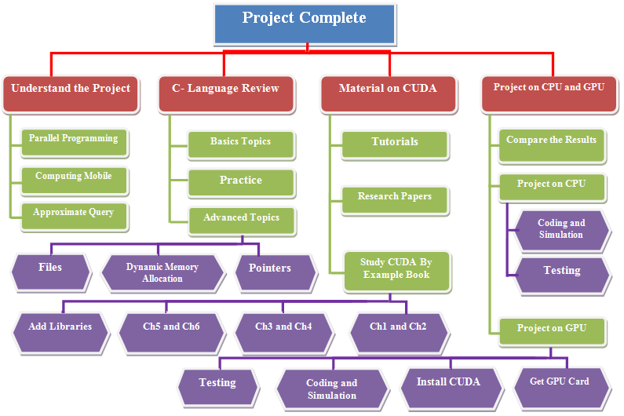

Figure 1.1 - WBS

1.9.2 Time Estimates

Figure 1.2 shows you “The time estimates schedule for the project”
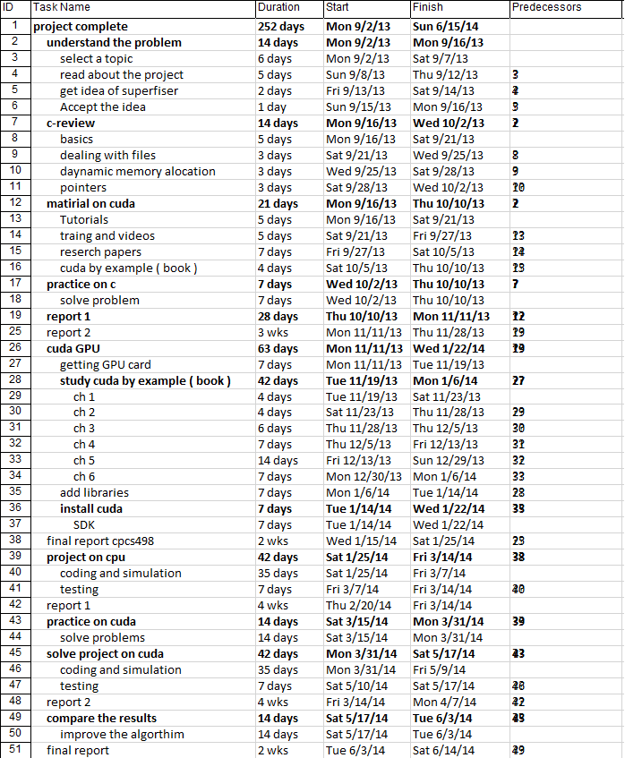
Figure 1.2 - Time Estimates

1.9.3 Gannt chart

The following Gannt chart diagram will illustrate the timing of the tasks which are already presented in the Work Breakdown Structure above. Gannt chart will help us to organize our time to finish the project on time.
Figure 1.2 shows you “The Gannt chart schedule for the project”

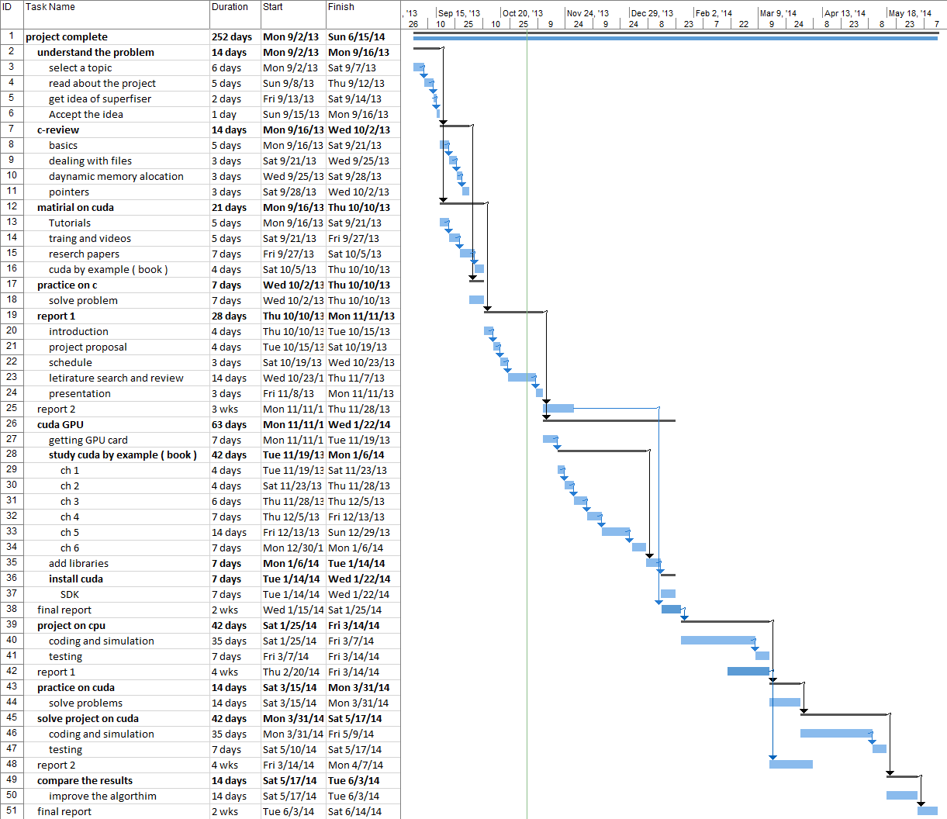
Figure 1.3 - Gannt chart

Chapter 2
Literature Review

Chapter 2 : Literature Search and Evaluation

2.1 Planning the literature search

We started by reading two research papers and the book of CUDA language given by the supervisor.

- Research papers :

- Aved, K. A. Hua, and A. Petkova, “Processing Approximate Moving Range Queries in Mobile Sensor Environments”.

- Aved, K. A. Hua, and A. Petkova, “CAWA: Continuous Approximate Where-About Queries”.

- Book :

- “CUDA by Example: An Introduction to General-Purpose GPU Programming”, J. Sanders, E. Kandrot, NVIDIA Corp, 2010.
2.2 Summary for the first reference:

“Processing Approximate Moving Range Queries in Mobile Sensor Environments”.

At the beginning the researchers speaks about the demand of location detection based services because the noticeable increase of smart mobile devices ,wireless network technologies, localization technologies such as the GPS , smart mobile devices, radio frequency identifiers (RFID), and sensor networks.

Then, they considered an environment with continuous moving mobile objects, location-aware mobile sensors that sense the location of mobile devices within its range but due to the mobility nature of mobile devices the cannot detect the exact locations of the objects, then the sensor sends the locations to a database, the system process mobile location-dependent range queries over mobile objects to answer with a data set of locations. Then they asses their work by a simulation to find the quality, effectiveness of the results.

The purpose of the research is to describe the imprecision of the data collected from the environment and to quantify the uncertainty that the query answers carry.

To solve this problem they provided a new class of probabilistic technique called Approximate Moving Range (AMR) Queries, Each query is concerned with finding which moving objects are located within its range; all query regions have the same range .then AMR query applied to a moving object with no location-detection capabilities. By fusing location information on moving objects detected by the individual mobile sensors, the database server evaluates the AMR Queries.

The researchers concludes that the AMR Query is scalable and effective, as a result of the only thing we need is mobile sensors with location positioning and communication devices.

2.2.1 Problem definition

The problem is divided into two parts:

- Uncertainty model :
The model distinguishes between two types of Mobile objects, targets and sensors, deployed in a two-dimensional area.

- Approximate Moving Range Queries :
Applying the approximate range queries, due to the lack of precise location information about the moving objects .Each query is pinned to one of the uncertain objects in the environment.

2.2.2 Solution

AMR query processing (solution) :

The user (object) will make an AMR Query (Q_{k=1,2,…}) with an id of a targeted object, (O_{k=1,2,…}) symbol refer to a query point to the object ,the server will deal with the Uncertain area (U_{k=1,2,…}) because of the continuous movement of the (O_{k}). (U_{k}) is used in the process of query evaluation (prediction). And the server deals only with the whereabouts of each targeted object, by the (U_{k}) s the server decide whether the targeted objects are in the result set of a particular AMR query or not.

In order to evaluate the AMR query we will divide it into three aspects :-

- Data Structures : Describes the data structures stored on the central server.

- Object Detection : Presents the algorithm for object detection

- Query Evaluation : Describes the AMR query evaluation algorithm.

2.2.3 Evaluation

Simulation study to present & analyze the finding results of the AMR query processing technique, and it’s divided into two parts:

- Experimental setup.
They designed a simulator of moving object environment to evaluate the AMR query model.

- Simulation results
In order to validate the query model they presented three kinds of results:

- Effect of Qualification Threshold.
Study the relationship between the threshold parameter and the sensor range, in which affects the accuracy and identifying the correct objects.

- Effect of Query Range.
Study the relationship between sensor range and query range, in which it affects the improvement of the results.

- Effect of Coverage.
Study the relationship between coverage area and number of sensors, in which affects the quality and correctness.

We have chosen this paper because it has a good description to the problem, clear guide to the solution and simulation study to validate the solution.

The paper is helpful because it provide a new class of query called an Approximate Moving Range (AMR) query to solve the project problem.

2.3 References :-

“CUDA by Example” book
Table 2.1 shows you “The evaluation for the CUDA by example book”
Prompt Criteria | Comments
Presentation | The information in the book are clear. Also, the language , layout and structure are very clear and easy to read . The diagrams and figures are very nice .The book is written for developers who want learn CUDA C .
Relevance | This book gives us all the information we need for our project. We will use this book to learn CUDA C Programing. This book is the best sources to learn CUDA C programming.
Objectivity | The authors have a clear goal in the book ( teach CUDA C language ), the book published by NVIDIA Corp.
Method | the data collected are clear and we trust the data because the result were clear and right.
Provenance | This book is written by two senior software engineers for the CUDA Platform group at NVIDIA. First , Jason received his master’s degree in computer science from the University of California Berkeley where he published a research in GPU computing. Second , Edward has more than 20 years of industry experience focused on optimizing code and improving performance .
Timeliness | Text printed in the United States on recycled paper at Edwards Brothers in Ann Arbor, Michigan. First printing, July 2010

Table 2.1 - The CUDA by example book evaluation
“Processing Approximate Moving Range Queries in Mobile Sensor Environments” research paper

Table 2.2 shows you “The evaluation for the Processing Approximate Moving Range Queries in Mobile Sensor Environments research paper”

Prompt Criteria | Comments
Presentation | The language ,layout, structure & figures are very clear to be read , the audience are continuous mobile location computing.
Relevance | The paper matches out what we need , it have a problem which is the same problem that we have , and it has a solution to our problem and it’s the paper we need to understand and solve our project better.
Objectivity | The authors stated their position in which how they will solve the problem , the paper is trusted because it is published at 2009 by IEEE
Method | All the information and the data are clear in the paper
Provenance | The paper came from School of EECS  University of Central Florida Orlando, USA . and its published at IEEE ,2009
Timeliness | The paper meets to our needs and its published at CSE-09 international conference , 2009 – IEEE .

Table 2.2 - Processing Approximate Moving Range Queries in Mobile Sensor Environments evaluation
“CAWA: Continuous Approximate Where-About Queries” research paper

Table 2.3 shows you “The evaluation for the CAWA: Continuous Approximate Where-About Queries research paper”

Prompt Criteria | Comments
Presentation | The paper have a clear language ,layout, structure and figures . the paper is written to the privacy aware devices in which they do not provide the exact of their location instead they provide near location from the exact .
Relevance | The paper have quite similar problem to our project problem in which we can make benefit from its solution and algorithm to solve our problem.
Objectivity | The authors stated their position in which how they will solve the problem , the paper is trusted because it is published at 2009 by SPRINGER .
Method | All the information and the data are clear in the paper.
Provenance | The paper came from School of EECS 4000 Central Florida Blvd Orlando, Florida, USA . and its published at SPRINGER ,2009
Timeliness | The paper meets to our needs and its published at Scalable Information Systems, 2009 – Springer.
Table 2.3 - CAWA: Continuous Approximate Where-About Queries research paper evaluation

Comparing the methods for finding the information:
The methods are : the book of CUDA and the research papers .
- The book teach us the CUDA language .
- The papers helps us in finding the appropriate solution to our proposed problem by providing an algorithm and a lot of information to help us continue our progress.

2.4 Skills

The main skills needed are :-

- Understand the term “Mobile Computing”.
- Understand the parallel programming.
- C Language.
- CUDA C Language.
- Management skills.
- Problem solving skills.
- Knowledge about algorithms.

We need to learn the language CUDA , understand the concepts of parallel programming in order to solve the approximate queries .

Also, we need to organize and manage the tasks in order to follow-up the planned schedule .

The most important skills are :-

- The term “Parallel Programming” :-

The term Parallel programming help us in diving our large problem smaller ones running concurrently (“in parallel”) .

- CUDA C :-
CUDA (Compute Unified Device Architecture) is a programming language created by NVIDIA and implemented by the (GPUs). CUDA gives direct access to instruction set and memory of CUDA GPUs.
By using CUDA, the GPUs can be used for general purpose programming. Unlike CPUs, however, GPUs have a parallel throughput architecture that executes many concurrent threads slowly, rather than executing a single thread very quickly as in the CPU.
CUDA C language is an important skill for us in which it’s the language that communicate with the GPU. By CUDA C we can access GPU directly and use all the threads on the GPU card .

- Management Skills :-

Management skills is an important skill, because it will help us in organizing the important tasks at the right time in order to finish the project on time.

Chapter 3

Analysis & design

Chapter 3 : Analysis & design

3.1 Requirements Specification

3.1.1 Functional Requirements :-

- Simulate an environment with continuous moving objects.
- Find exact & approximate locations by an algorithms.
- Compare & evaluate the performance between the CPU & the GPU.

3.1.2 Nonfunctional Requirements :-

- Response time.
- Throughput.
- Reliability.
- Maintainability.

3.2 Data Requirements :-

The xCoordinate & yCoordinate for every object and the query range.

3.3 Hardware :-

We need GPU NVidia card supports CUDA in order to do parallel computations.

3.4 Software :-

- Microsoft visual studio ( C Language ) , C is an interface to the CUDA platform.
- Windows 8 .
- CUDA SDK 5.5 .
- CUDA Device Driver.
- NVIDIA NSight Visual Studio Edition Tool , it brings parallel programming on the (GPU) into visual studio.
- Microsoft Visio ( To design the project ).

3.5 Activities and Actions

3.5.1 Use case diagram :-
Table 3.1 shows you “The use case diagram which shows you what kind of query the user can choose from”

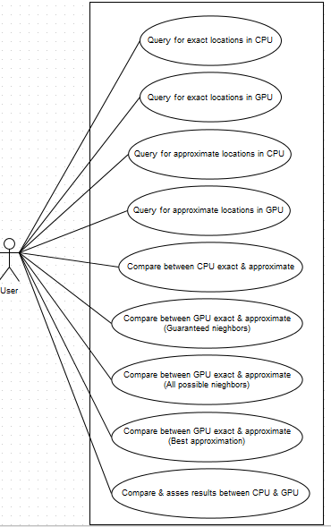

Table 3.1 - Use case diagram

3.5.2 Flow chart :-
Table 3.2 shows you “The flow chart which explains to you how the system will work”
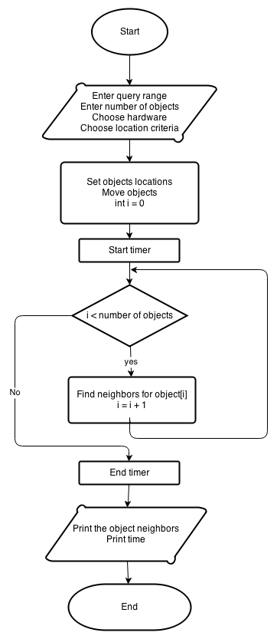
Table 3.2 - Flow chart

3.5.3 Class diagram :-
Table 3.3 shows you “Class diagram which shows to you the role of the server and the role of the client”
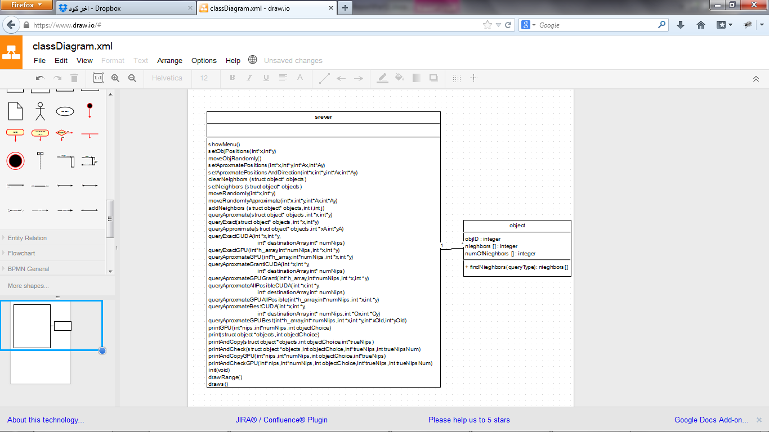

Table 3.3 - Class diagram

ER (Entity Relationship) diagram :-

Our project does not need a database , and according to our supervisor we just need to store real-time data in a data structure ( Arrays ) .

Tool ( software ) used for design :-

Microsoft Visio .

Chapter 4
Implementation

Chapter 4 : Implementation

4.1 The coding is divided into 10 parts :
- Simulate an environment with continuously moving objects.
- Find exact location by an algorithm in CPU.
- Find exact location by an algorithm in GPU.
- Find approximate location by an algorithm in CPU.
- Find approximate location by an algorithm in CPU.
- Compare the results between CPU exact and approximate locations.
- Compare the results between GPU exact and approximate locations (Guaranteed neighbors).
- Compare the results between GPU exact and approximate locations (All possible neighbors).
- Compare the results between GPU exact and approximate locations(Best approximation).
- Compare & assess the results between the CPU & the GPU.

4.2 Maintenance
We maintained the program by making a lot of tests in order to remove the errors.

4.3 Interface

The interface is a command line interface ( because the project is simulation-based type ).
The interface :
- The user need to enter a choice from the list.

Figure 4.1 shows you “That the user need to enter a choice from the list”
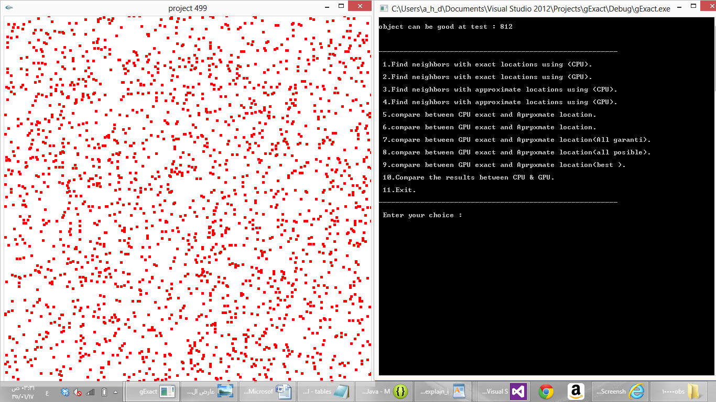
Figure 4.1 - choice entering

5
- The system will suggest an object ID , in order to fit the OpenGL screen ( the screen cannot show thousands of objects because the PC screen is small ) so the system will provide a candidate object to find his neighbors.

Figure 4.2 shows you “That the user needs to type the ID of the object in order to display the neighbors”
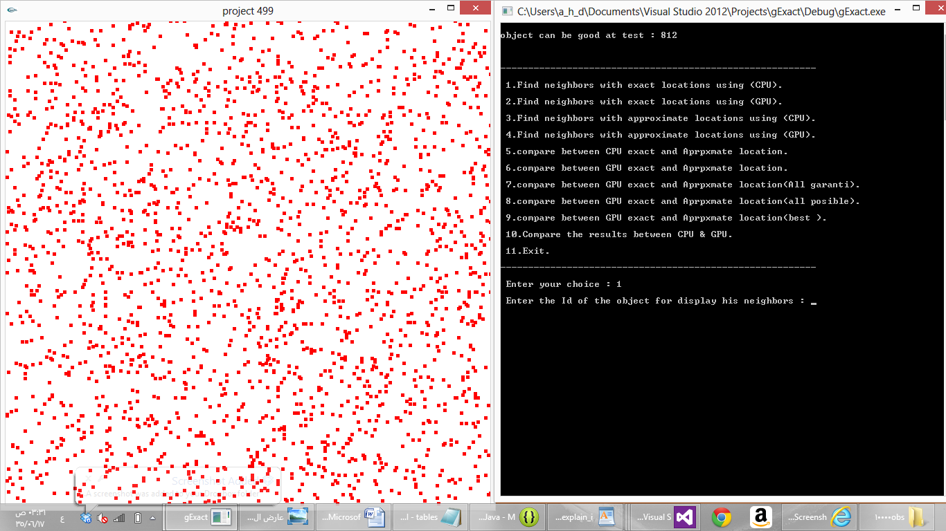
Figure 4.2 – Object ID entering

- The user needs to type the ID of the object in order to display the neighbors.

Figure 4.3 shows you “That After typing an ID the object will marked with a blue color and a blue range around the object will be created”
Figure 4.3 – Blue circle around the object
- After typing an ID the object will marked with a blue color and a blue range around the object will be created.

Chapter 5

Testing

Chapter 5 : Testing

We did a unit test in order to test each part ( Query type ) of the system to check the correctness of the results. We check the correctness of the results by comparing the results between CPU & GPU and by visualizing the simulation in order to see and count the objects that falls within the range.

5.1 Some of the test cases :
- Location : Approximate
Number of objects = 10000

Figure 5.1 shows you “Compare the results between CPU exact and approximate locations”
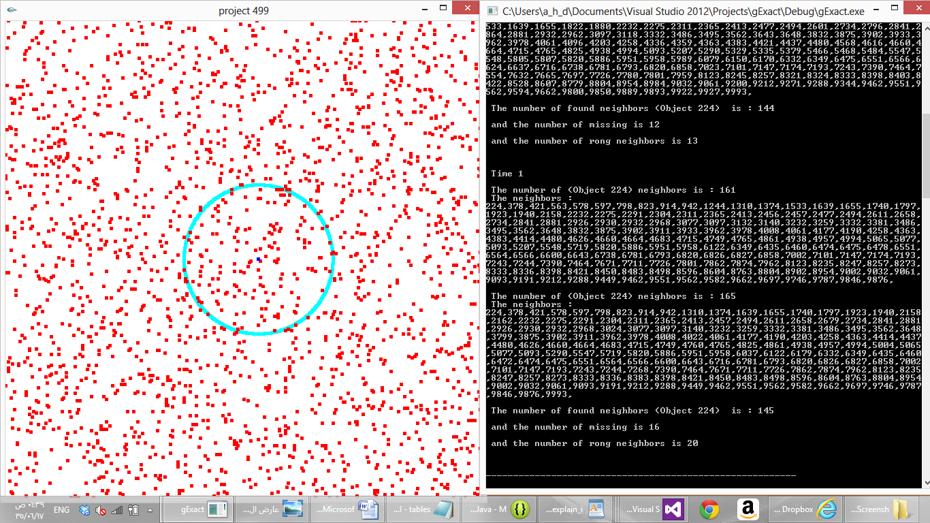
Figure 5.1 – Compare CPU exact & approximate

Figure 5.2 shows you “Compare the results between GPU exact and approximate locations (Guaranteed neighbors)”
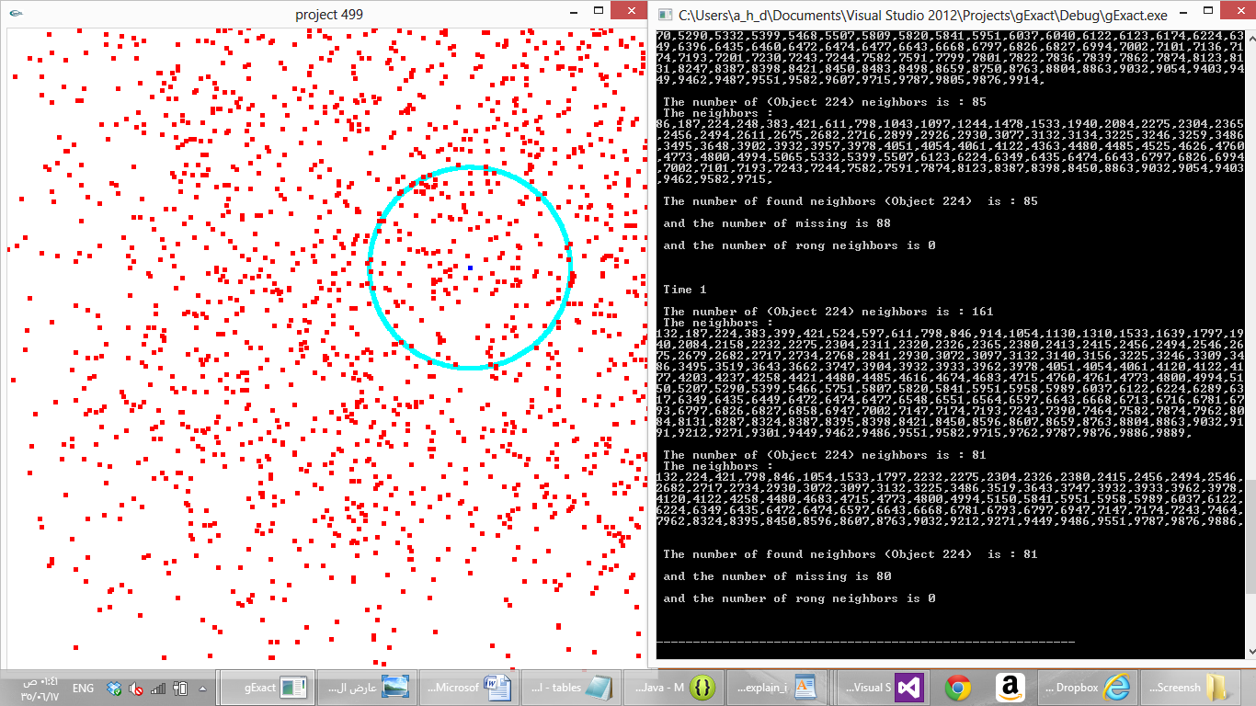
Figure 5.2 – Compare GPU exact & approximate (Guaranteed neighbors)

Figure 5.3 shows you “Compare the results between GPU exact and approximate locations (All possible neighbors)”
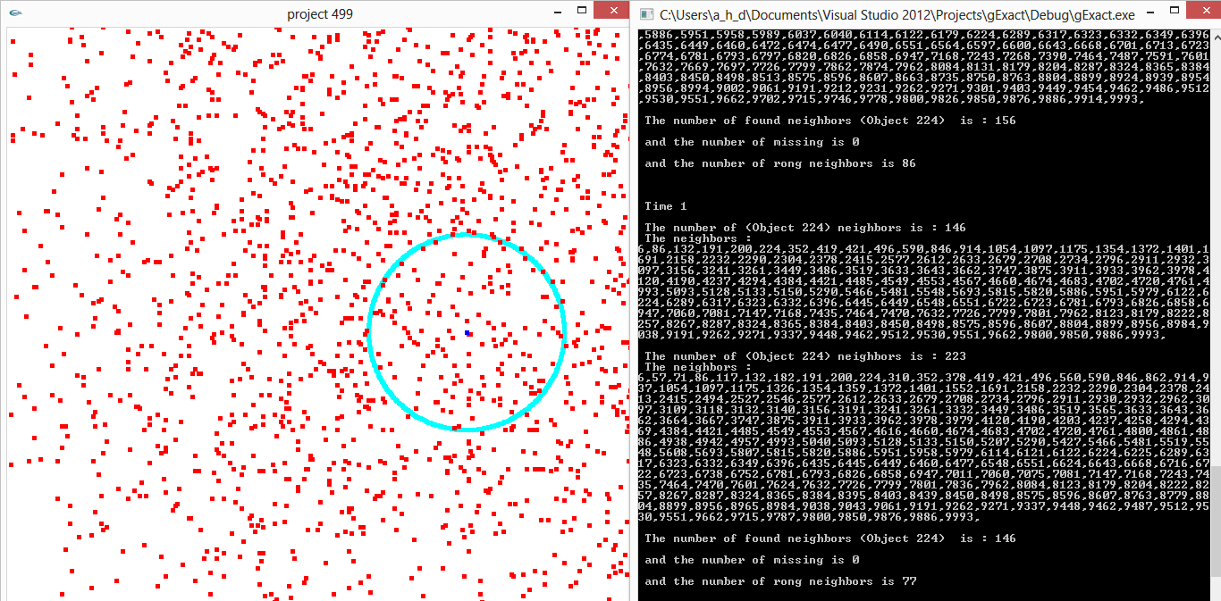
Figure 5.3 - Compare GPU exact & approximate (All possible neighbors)

Figure 5.4 shows you “Compare the results between GPU exact and approximate locations (Best approximation).
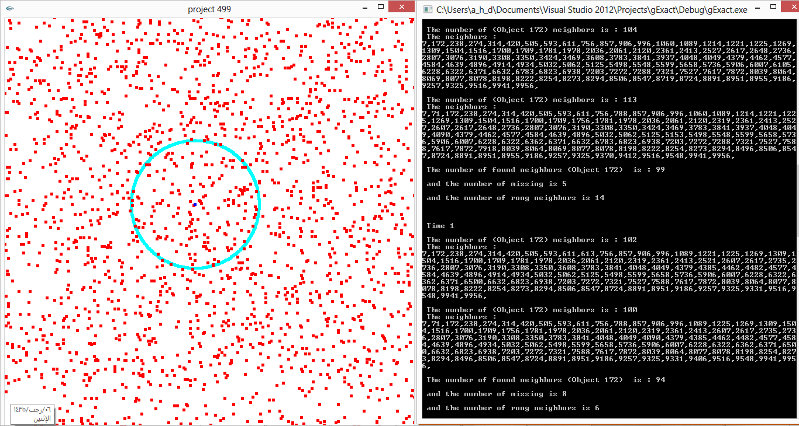

Figure 5.4 - Compare GPU exact & approximate (Best approximation)

5.2 Compare , Assess The Results

Table 5.1 shows you “Comparison between CPU & GPU exact queries with different num. of objects”
Num. of objects | Iterations | CPU time | GPU  time speedup
10000 | 10 | 0.828 | 0.145 | 5.71
10000 | 10 | 0.873 | 0.145 | 6.02
20000 | 10 | 3.527 | 0.518 | 6.808
20000 | 10 | 3.506 | 0.52 | 6.742
30000 | 10 | 7.873 | 1.156 | 6.81
30000 | 10 | 7.873 | 1.156 | 6.81
40000 | 10 | 14 | 2 | 7
40000 | 10 | 14 | 2.1 | 6.666
Table 5.1 – Test compare CPU & GPU exact (Num. of objects)

Figure 5.5 shows you “Comparison between CPU & GPU exact queries with different num. of objects”
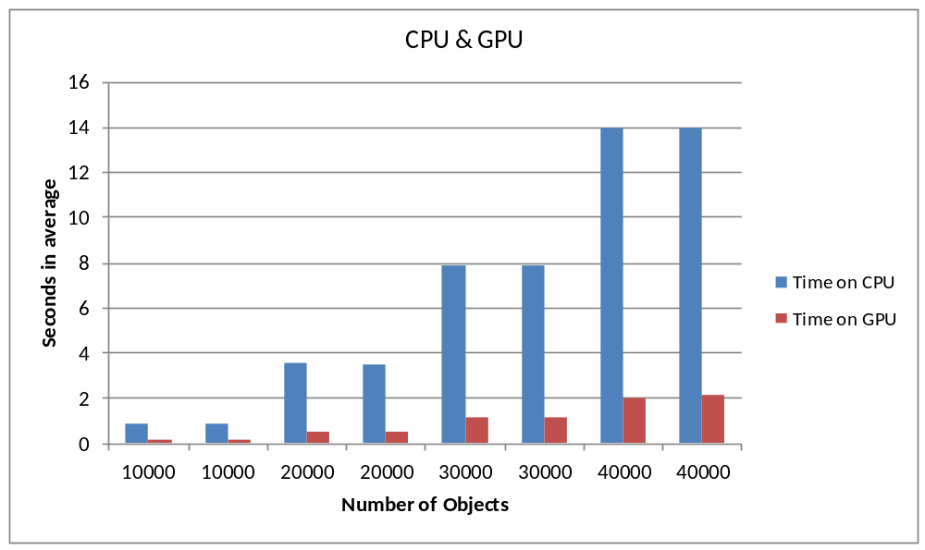
Figure 5.5 – Test compare CPU & GPU exact (Num. of objects)
Table 5.2 shows you “Exact query in GPU with different num. of threads”
Num. of Threads | Num. of objects | Iterations | GPU time
32 | 20000 | 10 | 1.09
64 | 20000 | 10 | 0.63
128 | 20000 | 10 | 0.526
256 | 20000 | 10 | 0.503
512 | 20000 | 10 | 0.507
1024 | 20000 | 10 | 0.528
Table 5.2 – Test GPU exact (Num. of threads)

Figure 5.6 shows you “Exact query in GPU with different num. of threads”
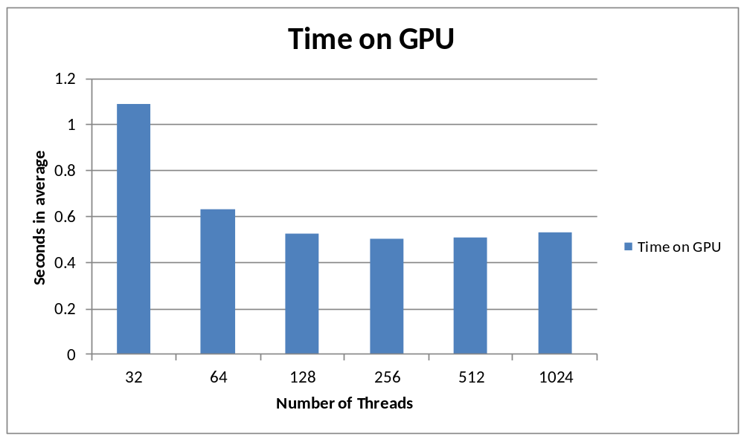
Figure 5.6 - Test GPU exact (Num. of threads)
Table 5.3 shows you “Exact query in GPU with different query range”
Query range | Num. of objects | Num. of neighbors | Iterations | GPU time
50 | 20000 | 15-20 | 10 | 0.515
100 | 20000 | 60-70 | 10 | 0.523
200 | 20000 | 290-300 | 10 | 0.567
500 | 20000 | 1600-1800 | 10 | 0.676
Table 5.3 – Test GPU exact (Query range)

Figure 5.7 shows you “Exact query in GPU with different query range”
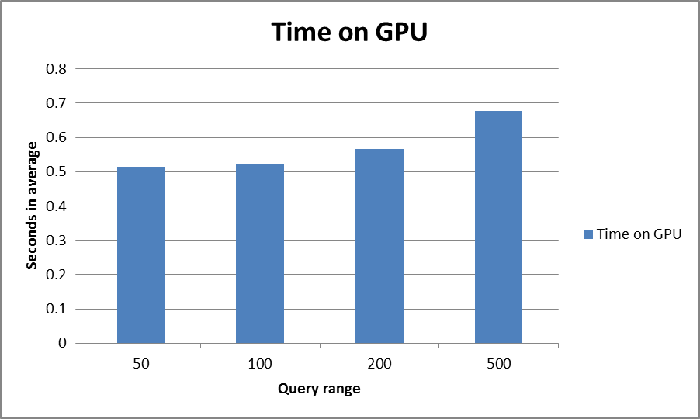
Table 5.7 - Test GPU exact (Query range)

Table 5.4 shows you “Approx. query vs. exact query in CPU”
grid size x : 1500 - grid size y : 1500 - moving range 20 - approximate range 20
selected object : 133 - number of objects : 15000 - query distance range 100
Iterations | Num. of real neighbors | Num. of approx. neighbors | Num. of missing neighbors | Num. of wrong neighbors | % Error missing neighbor | % Error wrong neighbors | % Error average
1 | 175 | 170 | 22 | 17 | 12.5% | 9.7% | 11.14%
2 | 194 | 192 | 23 | 21 | 11.8% | 10.8% | 11.3%
3 | 184 | 177 | 23 | 16 | 12.5% | 8.6% | 10.5%
4 | 194 | 186 | 23 | 15 | 11.8% | 7.7% | 9.7%
Average of all averages : |  |  |  |  | 12.1% | 9.2% | 10.7%
Table 5.4 – Test Approx. vs. exact CPU

Figure 5.8 shows you “Approx. query vs. exact query in CPU”
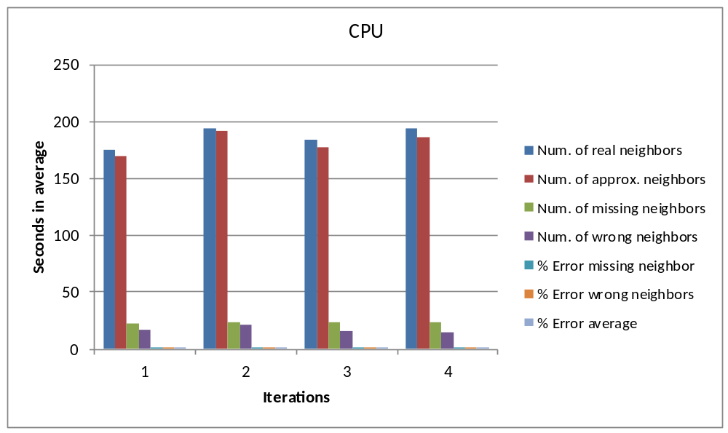
Figure 5.8 - Test Approx. vs. exact CPU
Table 5.5 shows you “Approx. query vs. exact query in GPU”
grid size x : 1500 - grid size y : 1500 - moving range 20 - approximate range 20
selected object : 133 - number of objects : 15000 - query distance range 100
Iterations | Num. of real neighbors | Num. of approx. neighbors | Num. of missing neighbors | Num. of wrong neighbors | % Error missing neighbor | % Error wrong neighbors | % Error average
1 | 155 | 157 | 21 | 23 | 13.5% | 14.8% | 14.1%
2 | 159 | 159 | 20 | 20 | 12.5% | 12.5% | 12.5%
3 | 171 | 172 | 23 | 24 | 13.4% | 14% | 13.7%
4 | 167 | 168 | 17 | 18 | 10.1% | 10.7% | 10.4%
Average of all averages : |  |  |  |  | 12.4% | 13% | 12.7%
Table 5.5 – Test Approx. vs. exact GPU

Figure 5.9 shows you “Approx. query vs. exact query in GPU”
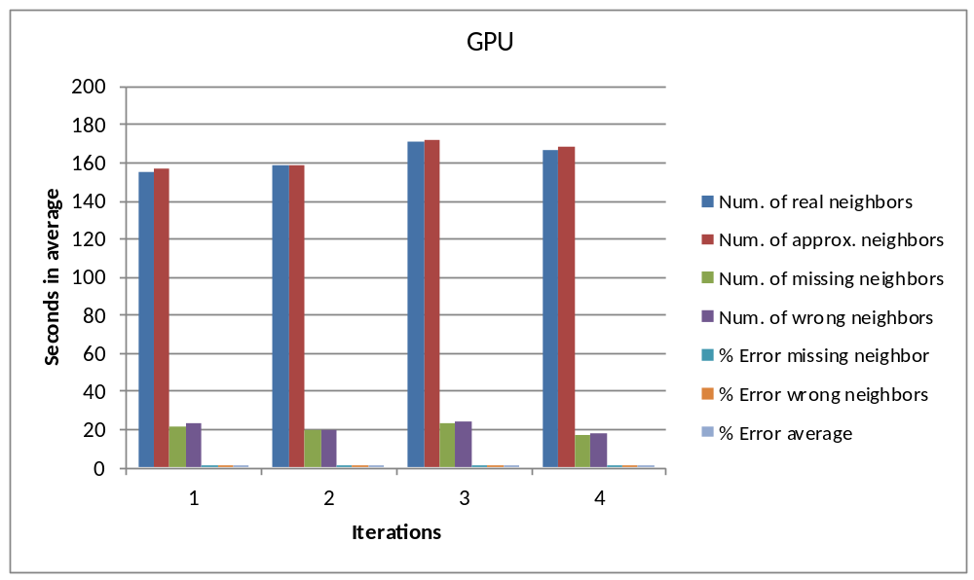
Figure 5.9 – Test Approx. vs. exact GPU

Table 5.6 shows you “Approx. query vs. exact query in GPU (Guaranteed neighbors algorithm)”
grid size x : 1500 - grid size y : 1500 - moving range 20 - approximate range 20
selected object : 133 - number of objects : 15000 - query distance range 100
Iterations | Num. of real neighbors | Num. of approx. neighbors | Num. of missing neighbors | Num. of wrong neighbors | % Error missing neighbor | % Error wrong neighbors | % Error average
1 | 182 | 89 | 93 | 0 | 51% | 0% | 25.5%
2 | 183 | 94 | 89 | 0 | 48.6% | 0% | 24.3%
3 | 188 | 99 | 89 | 0 | 47.3% | 0% | 23.6%
4 | 183 | 91 | 92 | 0 | 50.2% | 0% | 25.1%
Average of all averages : |  |  |  |  | 49.3% | 0% | 24.6%
Table 5.6 – Test Approx. vs. exact GPU (Guaranteed neighbors)

Figure 5.10 shows you “Approx. query vs. exact query in GPU (Guaranteed neighbors algorithm)”
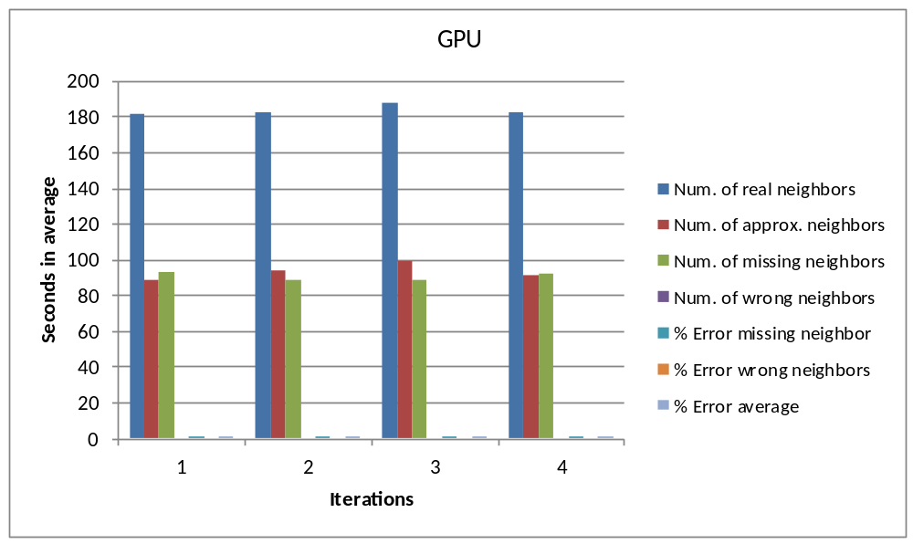
Figure 5.10 – Test Approx. vs. exact GPU (Guaranteed neighbors)
In Guaranteed neighbors algorithm we assign all the objects that falls inside (query neighbors range - movement range) as a neighbors.
Table 5.7 shows you “Approx. query vs. exact query in GPU (All possible neighbors algorithm)”
grid size x : 1500 - grid size y : 1500 - moving range 20 - approximate range 20
selected object : 133 - number of objects : 15000 - query distance range 100
Iterations | Num. of real neighbors | Num. of approx. neighbors | Num. of missing neighbors | Num. of wrong neighbors | % Error missing neighbor | % Error wrong neighbors | % Error average
1 | 165 | 250 | 0 | 85 | 0% | 51.5% | 25.7%
2 | 156 | 251 | 0 | 95 | 0% | 60.8% | 30.4%
3 | 159 | 248 | 0 | 89 | 0% | 55.9% | 27.9%
4 | 157 | 238 | 0 | 81 | 0% | 51.5% | 25.7%
Average of all averages : |  |  |  |  | 0% | 54.9% | 27.4%
Table 5.7 – Test Approx. vs. exact GPU (All possible neighbors)

Figure 5.11 shows you “Approx. query vs. exact query in GPU (All possible neighbors algorithm)”
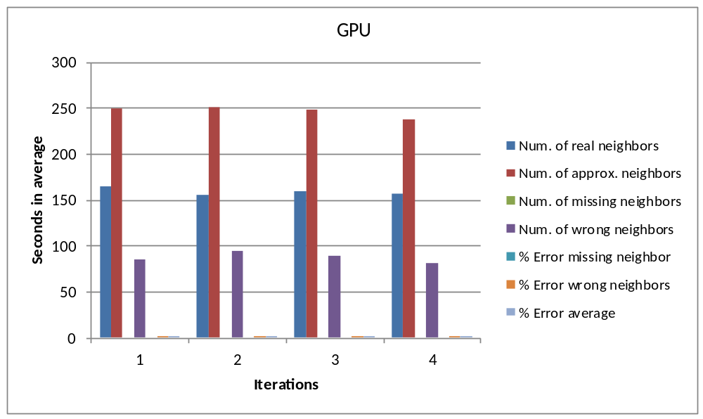
Figure 5.11 – Test Approx. vs. exact GPU (All possible neighbors)
In All possible neighbors algorithm we assign all the objects that falls inside (query neighbors range + movement range) as a neighbors.
Table 5.8 shows you “Approx. query vs. exact query in GPU (Best approximation algorithm)”
grid size x : 1500 - grid size y : 1500 - moving range 20 - approximate range 20
selected object : 133 - number of objects : 15000 - query distance range 100
Iterations | Num. of real neighbors | Num. of approx. neighbors | Num. of missing neighbors | Num. of wrong neighbors | % Error missing neighbor | % Error wrong neighbors | % Error average
1 | 162 | 167 | 15 | 20 | 9.2% | 12.3% | 10.8
2 | 172 | 166 | 22 | 16 | 12.7% | 9.3% | 11%
3 | 179 | 185 | 11 | 17 | 6.1% | 9.4% | 7.8%
4 | 201 | 201 | 17 | 17 | 8.4% | 8.4% | 8.4%
Average of all averages : |  |  |  |  | 9.1% | 9.9% | 9.5%
Table 5.8 – Test Approx. vs. exact GPU (Best approximation)

Figure 5.12 shows you “Approx. query vs. exact query in GPU (Best approximation algorithm)”
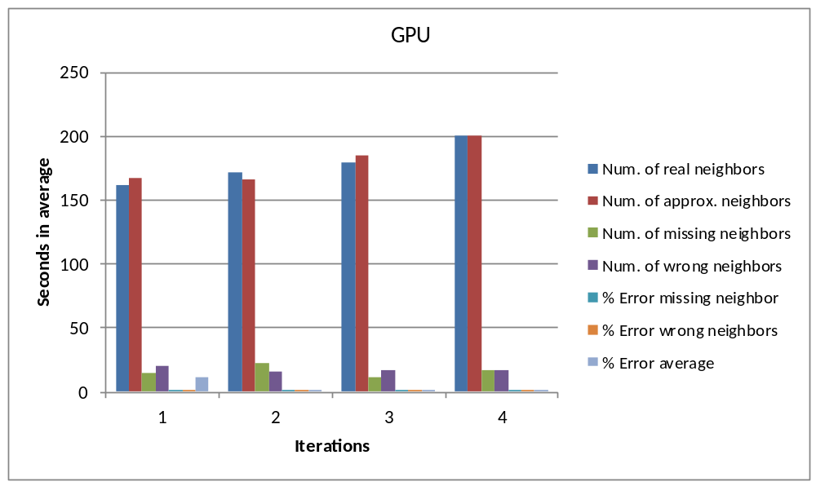
Figure 5.12 – Test Approx. vs. exact GPU (Best approximation)
In the Best approximation algorithm we assign all the objects that falls inside (query neighbors range - movement range) and by using the old approximate objects positions methodology as a neighbors.
The old approximate objects positions methodology :
- If the old objects positions and the current objects positions are inside the query range that's mean that the objects are moving towards the query range. So, we assign them as a neighbors.
- If the object positions are inside the query range but the old objects positions were outside the range that's mean that the objects are moving towards the query range. So, we assign them as a neighbors.
- If the old objects positions were inside the query range but the current objects positions are outside the range that's mean that the objects are moving outwards the query range direction. So, we don’t assign them as a neighbors.
the Best approximation algorithm is the best algorithm among the others because it has the least percentage of average of error.

5.3 Conclusion for testing phase
The results were good ,reasonable and as expected.

Chapter 6

Conclusion

Chapter 6 : Conclusion

In the end , the outcomes of the project are :
- Learn a new language (CUDA C) by NVIDIA's Corp. to make parallel computation.
- Solve a highly famous problem in the domain of real-time approximate query location (using GPU).
- Improve , assess and compare the performance between the CPU and the GPU.

List of References

6.1 List of references :-

6.1.1 Research papers :

- A. Aved, K. A. Hua, and A. Petkova, “Processing Approximate Moving Range Queries in Mobile Sensor Environments” , pp. 1-17 , CSE-09 international conference, 2009 – IEEE .

- A. Aved, K. A. Hua, and A. Petkova, “CAWA: Continuous Approximate Where-About Queries”, pp. 1-6 , - Scalable Information Systems, 2009 – Springer.

6.1.2 Book :

- “CUDA by Example: An Introduction to General-Purpose GPU Programming”, J. Sanders, E. Kandrot, NVIDIA Corp, 2010.

6.1.3 Definitions :

- GPU computing : http://www.nvidia.com/object/what-is-gpu-computing.html
- Parallel computing : http://en.wikipedia.org/wiki/Parallel_computing
- Mobile computing : http://www.doc.ic.ac.uk/~nd/surprise_96/journal/vol4/vk5/report.html
, http://users.ictp.it/~pub_off/preprints-sources/2010/IC2010102P.pdf

Appendix A
Code

Appendix A : Code

A.1 Important functions :-
sample text sample text sample text sample text sample text sample text sample text sample text sample text. Body text (Time New Romans, Size 12, Paragraph type justify)
// Defining identifiers

#define gridSizeX 1500 // Environment x-axis size
#define gridSizeY 1500 // Environment y-axis size
#define numOfObjects 20000 // The number of objects at the environmet
#define queryDistRange 50 // Query range in x-axis & y-axis
#define simuIteration 2 // Simulation iterations (number of simulation iterations)
#define objMovmentRange 10 // Maximum movment range in the x-axis & y-axis
#define maxNumOfNeighbors 10000000 // The maximum number of neighbors for each object
#define objMovementRangeApproximate 10 // Approximate range for the Query in x-axis & y-axis
#define maxNeighborPerObject (maxNumOfNeighbors/numOfObjects) // To determine the maximum number of neighbors per object
#define sizeOfNeighborArray 300
#define imin(a,b) (a<b?a:b) // Determine the minimum numeric value of the arguments
const int threadsPerBlock = 32; // Threads will be lunched per block
const int blocksPerGrid =imin( 32, (numOfObjects+threadsPerBlock-1) / threadsPerBlock ); // Blocks will be lunched per grid

// User defined Type
typedef struct object // Define a type called object
{
int *neighbors; // Each neighbor ID
int numOfNeighbors; // The number of neighbors for each object
} ;

// Initialize objects positions (random coordinates)
void setObjectsPositions (int*x,int*y)
{
int i;
srand((unsigned)time(0));
for (i = 0; i < numOfObjects; )
{
x[i] = rand() % gridSizeX + 1;
y[i] = rand() % gridSizeY + 1;
if(x[i]>gridSizeX || y[i]>gridSizeY)
continue;
else
i++;
}
}

//==================================================================================================
// Initialize objects approximate positions (random coordinates)

void setObjectsAproximatePositions(int*x,int*y,int*Ax,int*Ay){

int i, moveX, moveY;

for (i = 0; i < numOfObjects; i++)
{

moveX = (rand() % (objMovementRangeApproximate * 2 + 1)) - objMovementRangeApproximate;
moveY = (rand() % (objMovementRangeApproximate * 2 + 1)) - objMovementRangeApproximate;

Ax[i]=x[i]+ moveX;
Ay[i]=y[i]+ moveY;
}
}

//=============================================================================================================================
// Move the objects at random x & y coordinates
void moveRandomly(int*x,int*y){

int i, moveX, moveY;

for (i = 0; i < numOfObjects; i++)
{

moveX = (rand() % (objMovmentRange * 2 + 1)) - objMovmentRange;
moveY = (rand() % (objMovmentRange * 2 + 1)) - objMovmentRange;

if (x[i] + moveX > gridSizeX || x[i] + moveX < 0 || y[i] + moveY > gridSizeY || y[i]+moveY < 0)
{
continue;
}

x[i] += moveX;
y[i] += moveY;
}
}

//=============================================================================================================================

// Move the objects at random x & y coordinates with approximate positions

void moveRandomlyApproximate(int*x,int*y,int*Ax,int*Ay){

int i, moveX, moveY;

for (i = 0; i < numOfObjects; i++)
{

moveX = (rand() % (objMovmentRange * 2 + 1)) - 5;
moveY = (rand() % (objMovmentRange * 2 + 1)) - 5;

if (x[i] + moveX > gridSizeX || x[i] + moveX < 0 || y[i] + moveY > gridSizeY || y[i]+moveY < 0 || Ax[i] + moveX > gridSizeX || Ax[i] + moveX < 0 || Ay[i] + moveY > gridSizeY || Ay[i]+moveY < 0)
{
continue;
}
x[i] += moveX;
y[i] += moveY;
Ax[i] += moveX;
Ay[i] += moveY;
}
}

//==================================================================================================

// Adding neighbors for each object (if the neighbor(s) exists within the specified range)

void addNeighbors (struct object* objects,int i,int j)
{
if((objects[i].numOfNeighbors)>0 && objects[i].numOfNeighbors%sizeOfNeighborArray==0)
{
objects[i].neighbors=(int*)realloc(objects[i].neighbors,(objects[i].numOfNeighbors+sizeOfNeighborArray)*sizeof(int));
}
objects[i].neighbors[objects[i].numOfNeighbors]=j;
objects[i].numOfNeighbors++;
if((objects[j].numOfNeighbors)>0 && objects[j].numOfNeighbors%sizeOfNeighborArray==0)
{
objects[j].neighbors=(int*)realloc(objects[j].neighbors,(objects[j].numOfNeighbors+sizeOfNeighborArray)*sizeof(int));
}
objects[j].neighbors[objects[j].numOfNeighbors]=i;
objects[j].numOfNeighbors++;
}

//==================================================================================================

// Query to find for each object all the neighbors that falls within the range
void queryExact(struct object* objects,int *x,int*y) {

int i, j;
double euclideanDistance, dist;
for (i = 0; i < numOfObjects; i++)
{
for (j = i+1; j < numOfObjects; j++)
{
dist = (x[i] - x[j]) * (x[i] - x[j]) + (y[i] - y[j]) * (y[i] - y[j]) ;
euclideanDistance = sqrt(dist) ;
if (euclideanDistance <= queryDistRange)
{
addNeighbors(objects,i,j);
}
}
}
}
//==================================================================================================

// Query to find for each object all the neighbors that falls within the range
void queryAproximate(struct object* objects,int *x,int*y) {

